1. **INTRODUCTION**
   1. Overview

The world’s population is more than three times larger than it was in the mid-twentieth century.

The global human population reached 8.0 billion in mid-November 2022 from an estimated 2.5

billion people in 1950, adding 1 billion people since 2010 and 2 billion since 1998. The world’s

population is expected to increase by nearly 2 billion persons in the next 30 years, from the

current 8 billion to 9.7 billion in 2050 and could peak at nearly 10.4 billion in the mid-2080s.

This dramatic growth has been driven largely by increasing numbers of people surviving to

reproductive age, the gradual increase in human lifespan, increasing urbanization, and

accelerating migration. Major changes in fertility rate have accompanied this growth. These

trends will have far-reaching implications for generations to come.

* 1. Purpose

A population projection gives a picture of what the future size and structure of the population by sex and age might look like. It is based on knowledge of the past trends, and, for the future, on assumptions made for three components: fertility, mortality and migration.

1. **PROBLEM DEFINITION AND DESIGN THINKING** 
   1. Empathy Map

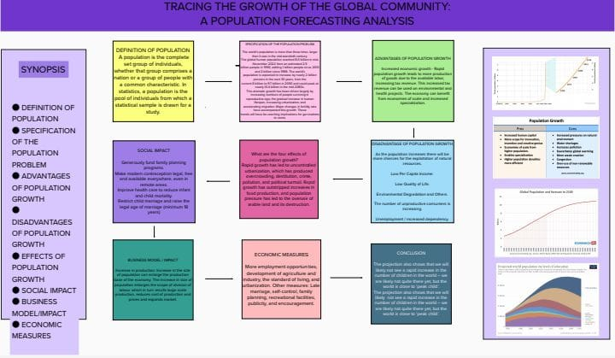

* 1. Ideation and Brainstorming Map

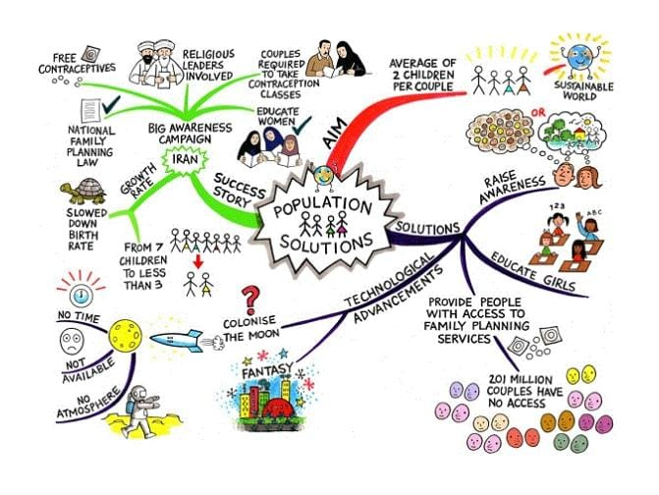

1. **RESULT**

According to our project report based on the census of countries like Albania, American Samoa, Andora, Armenia, Aruba, Australia, Austria, Azerbaijan, Bahamas, Bangladesh and Belarus we have come to a decision that Australia has the highest population.

**DATA VISUALIZATION**

Activity 1.1 Population records by types of countries

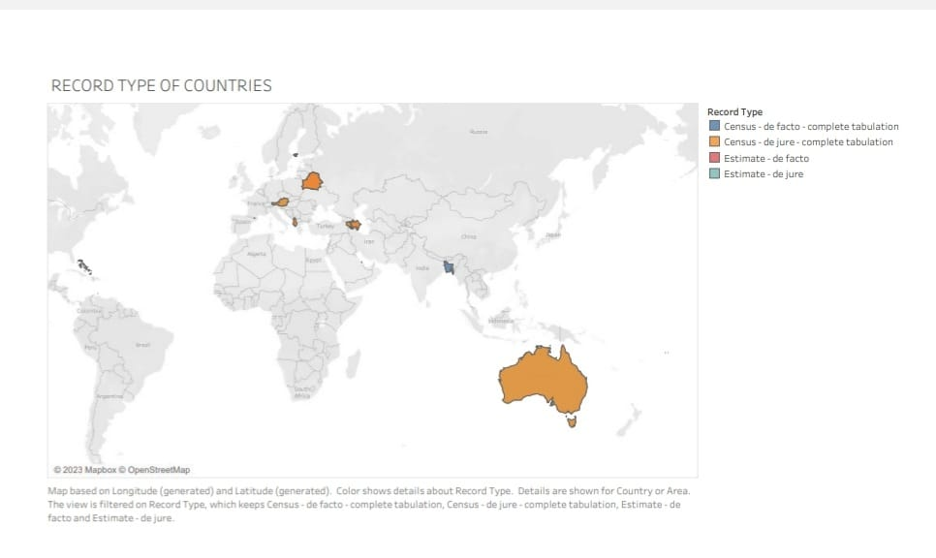

Activity 1.2 Population trends over the years

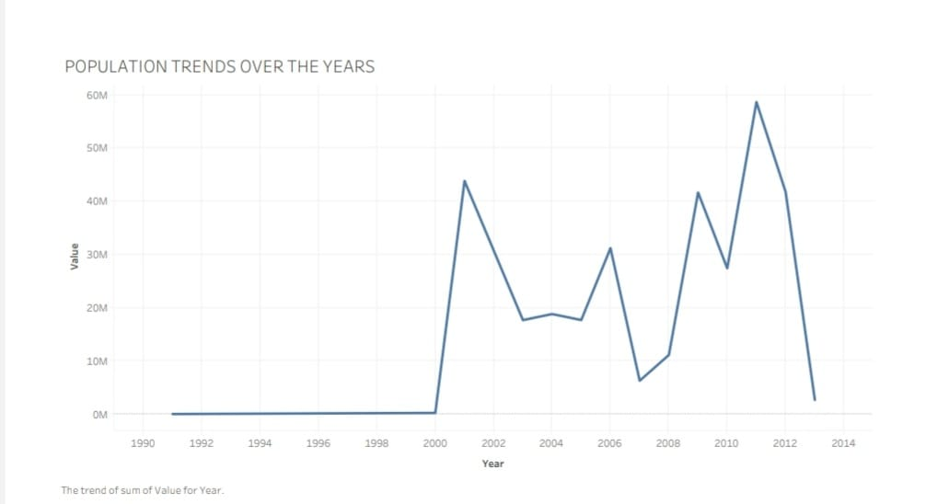

Activity 1.3 Population trends over the years by sex

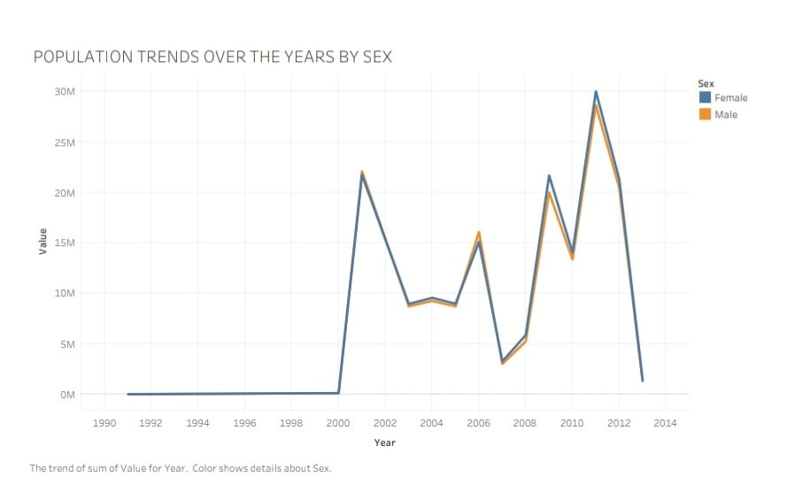

Activity 1.4 Cities with highest average populations

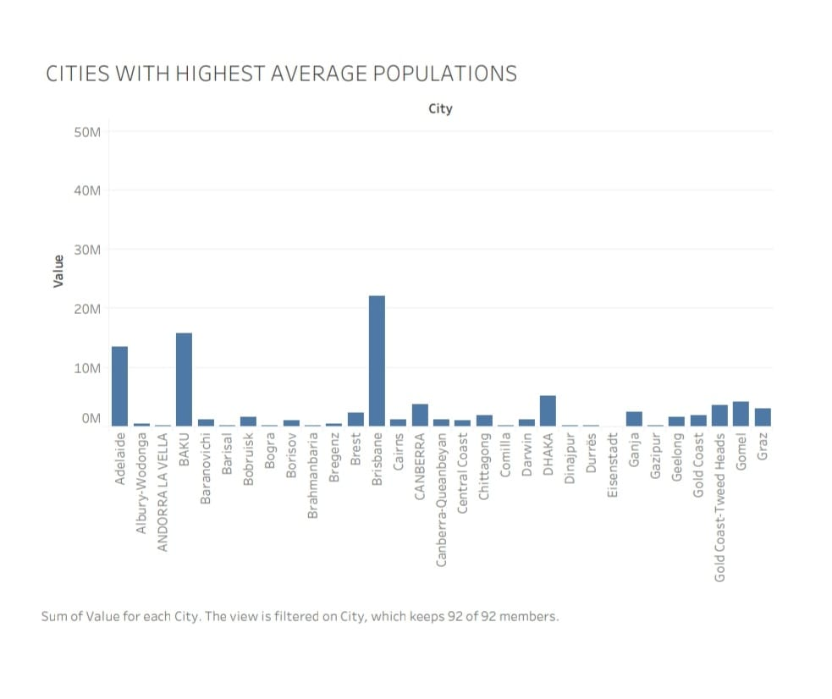

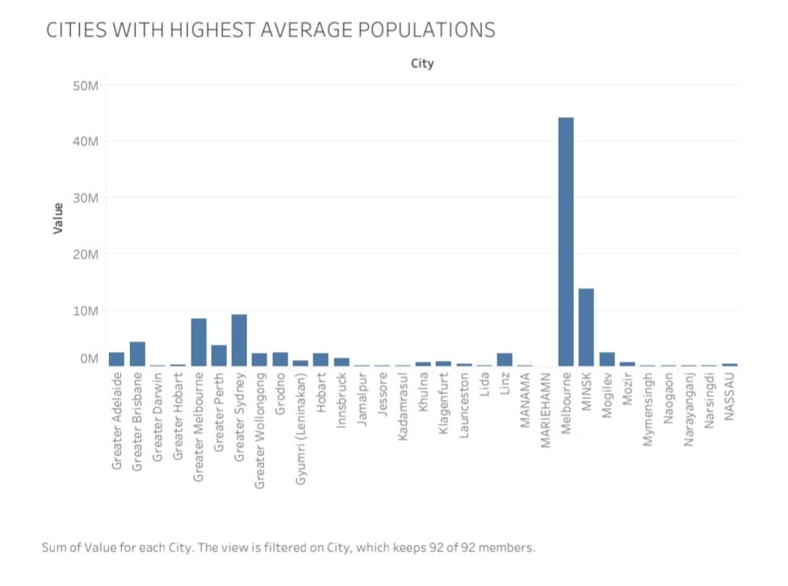

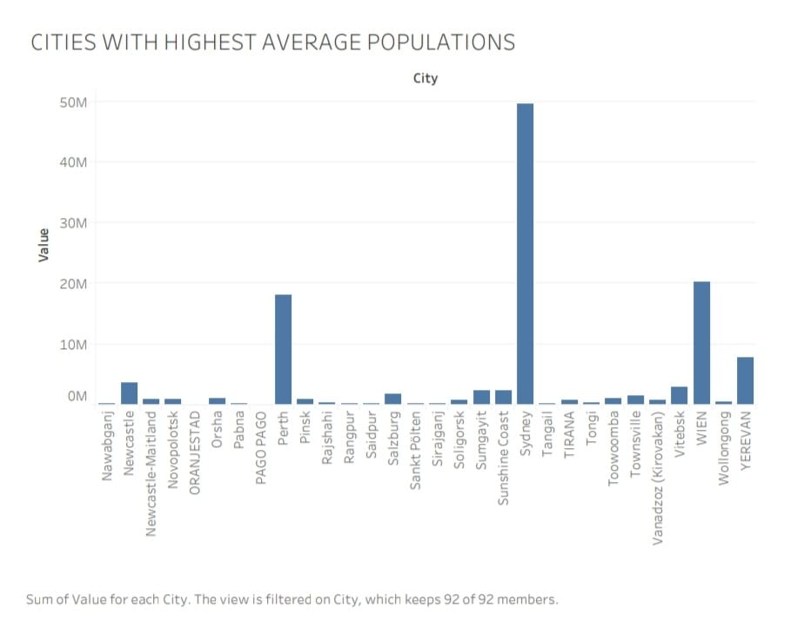

Activity 1.5 Countries with highest average population from 2000 – 2014

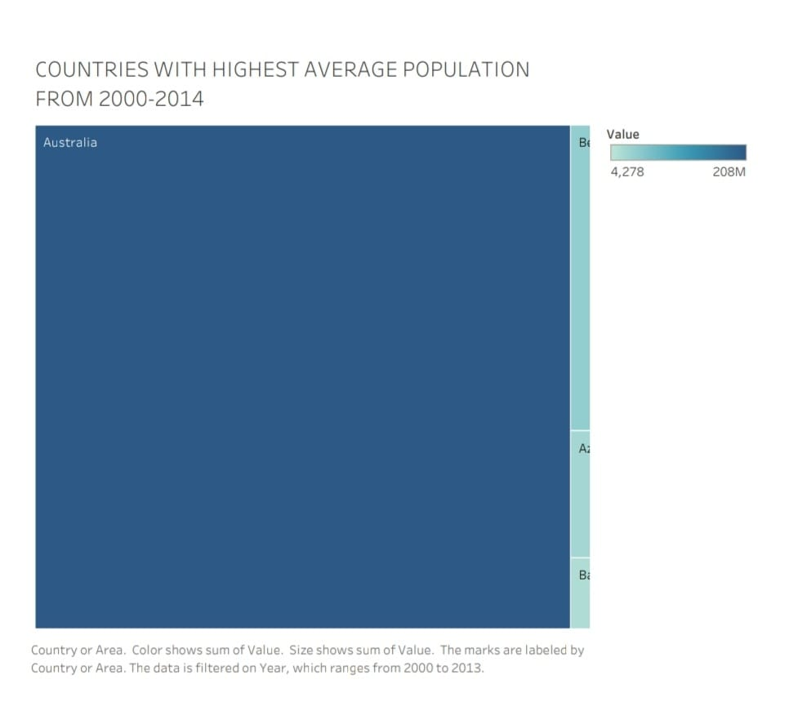

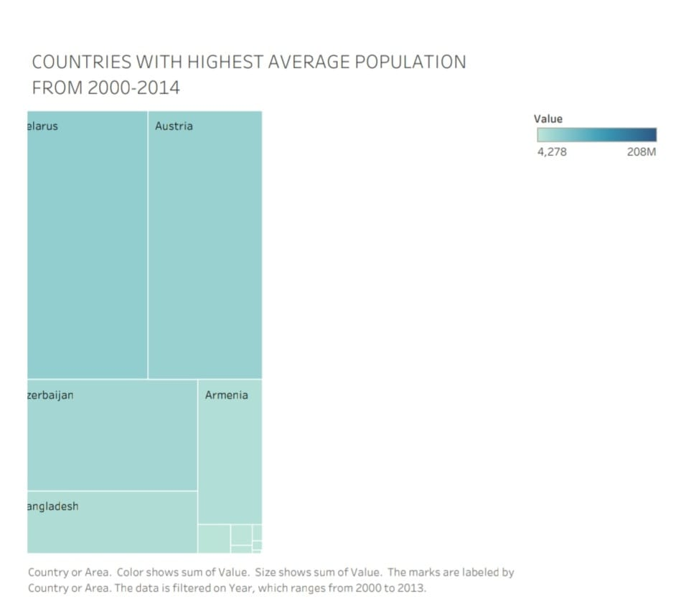

Activity 1.6 Population by city type

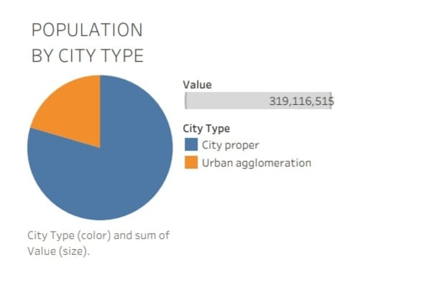

Activity 1.7 Population of cities by year

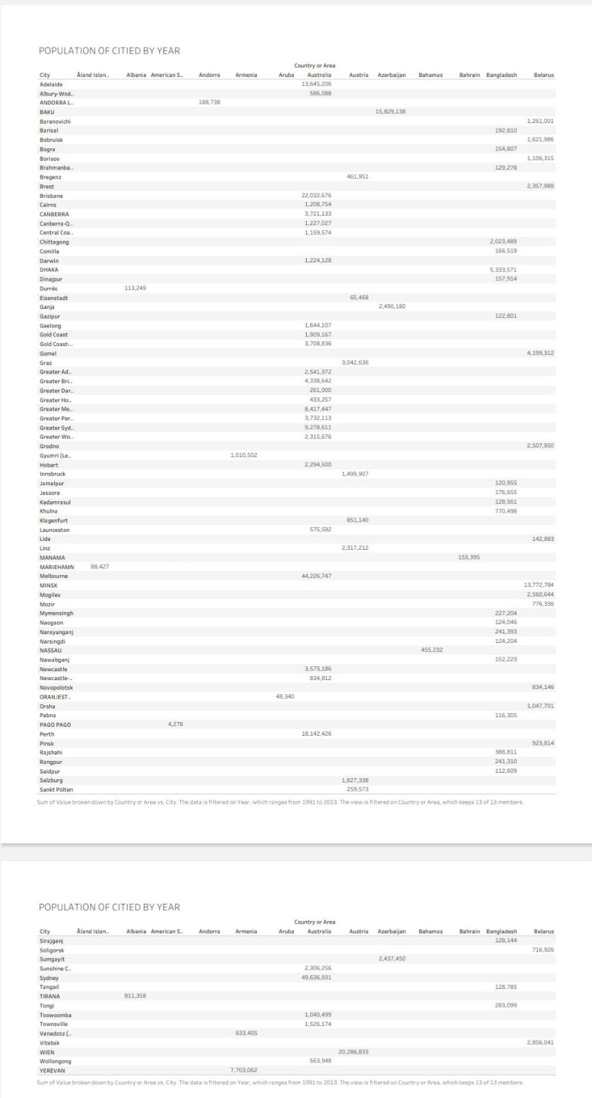

**DASHBOARD**

Responsive and Design of Dashboard

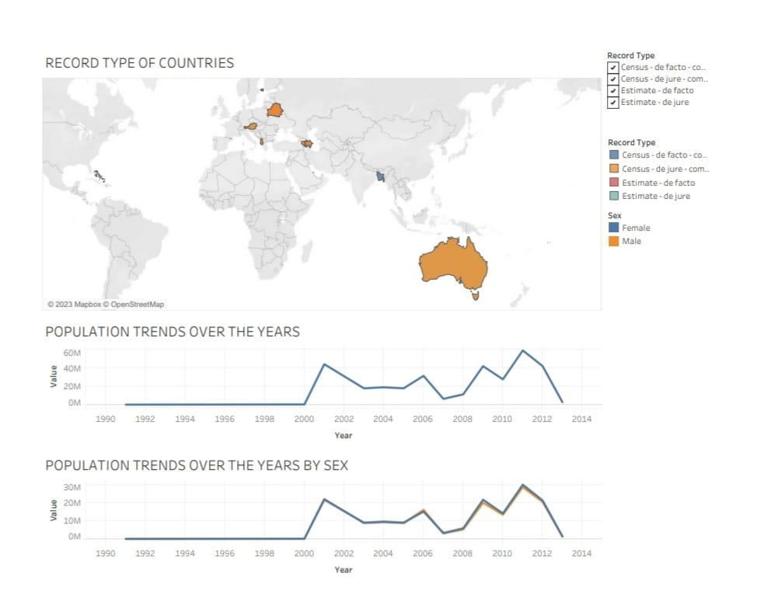

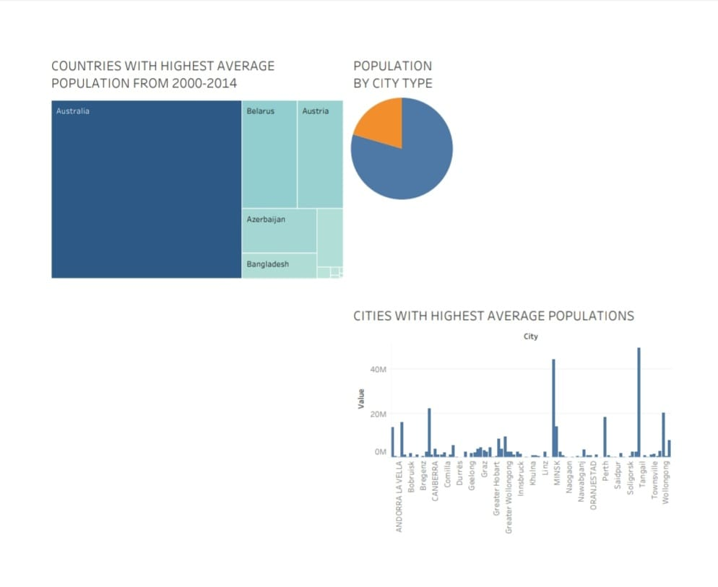

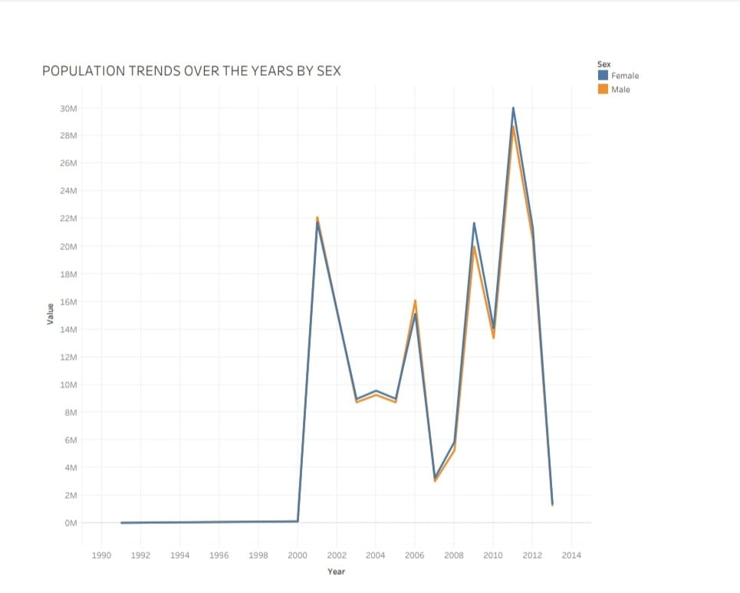

**STORY**

No of Scenes of Story

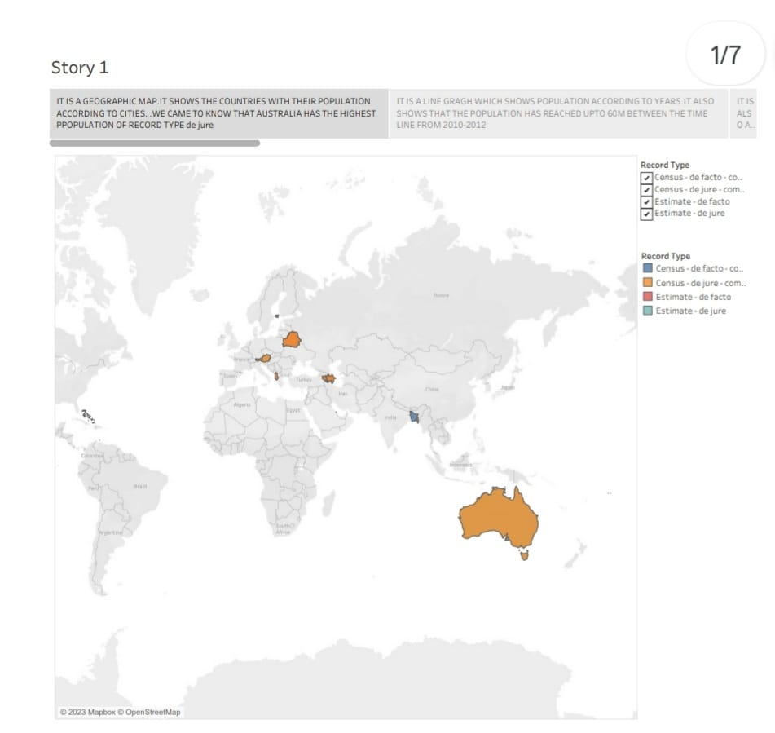

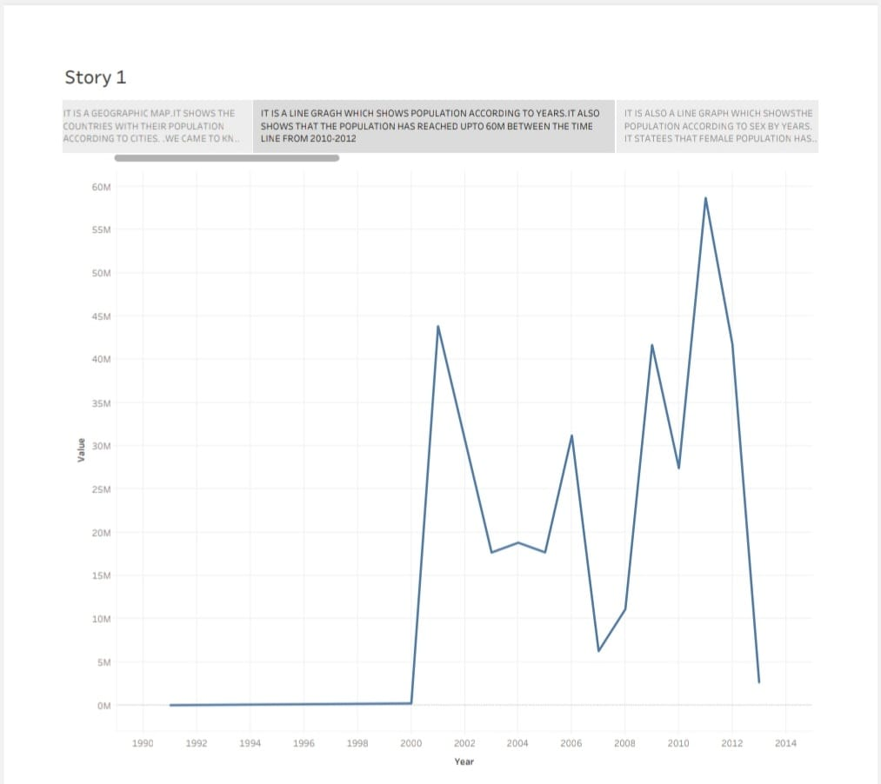

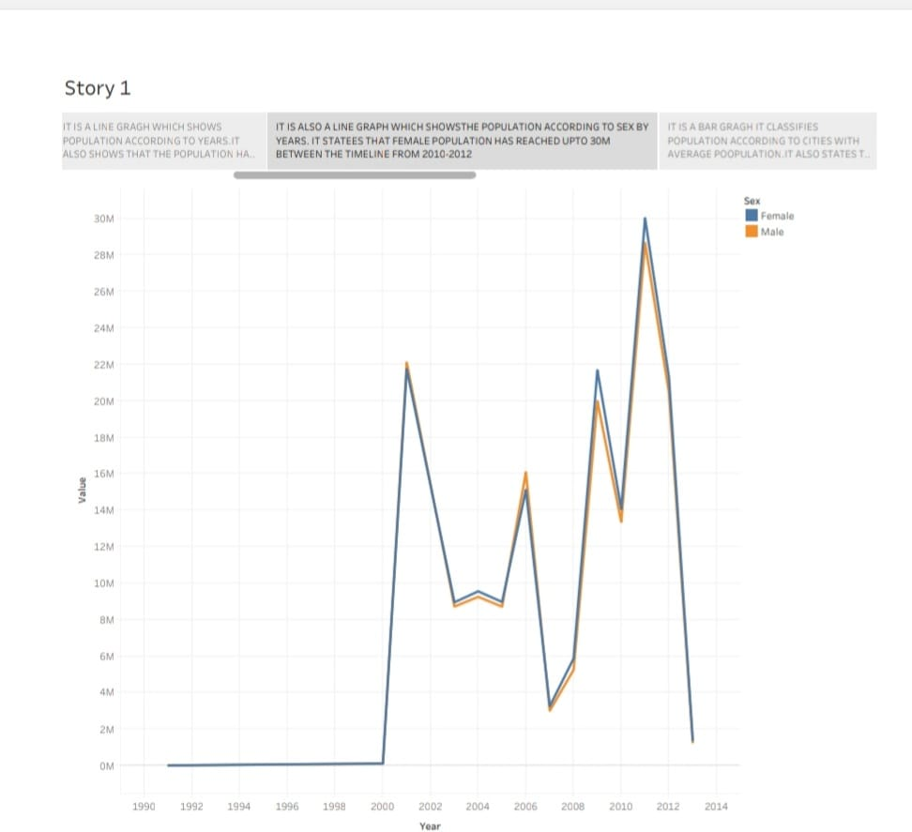

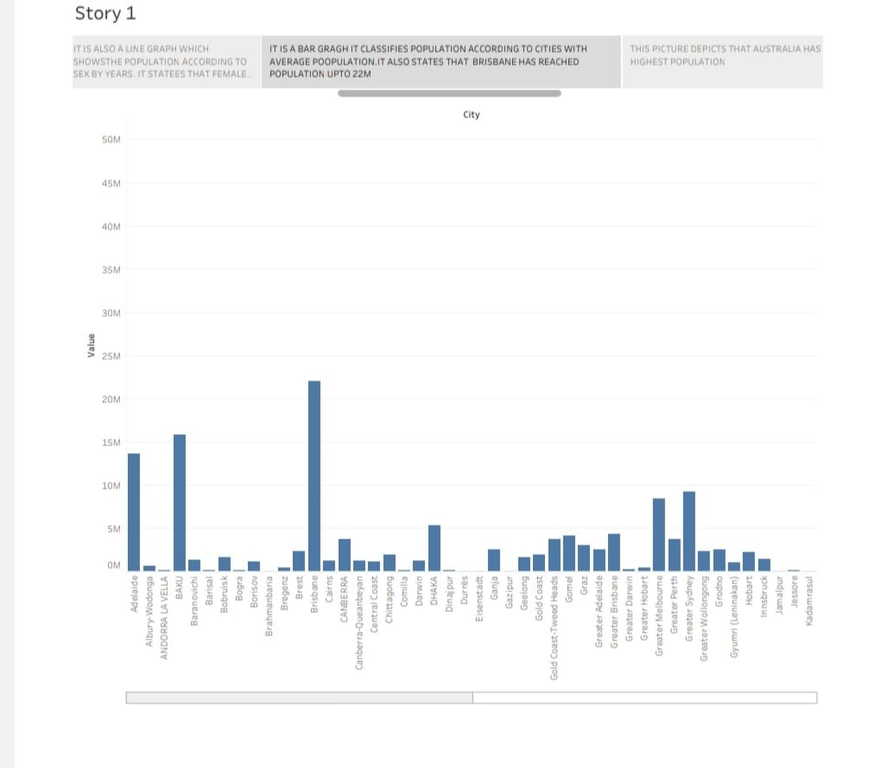

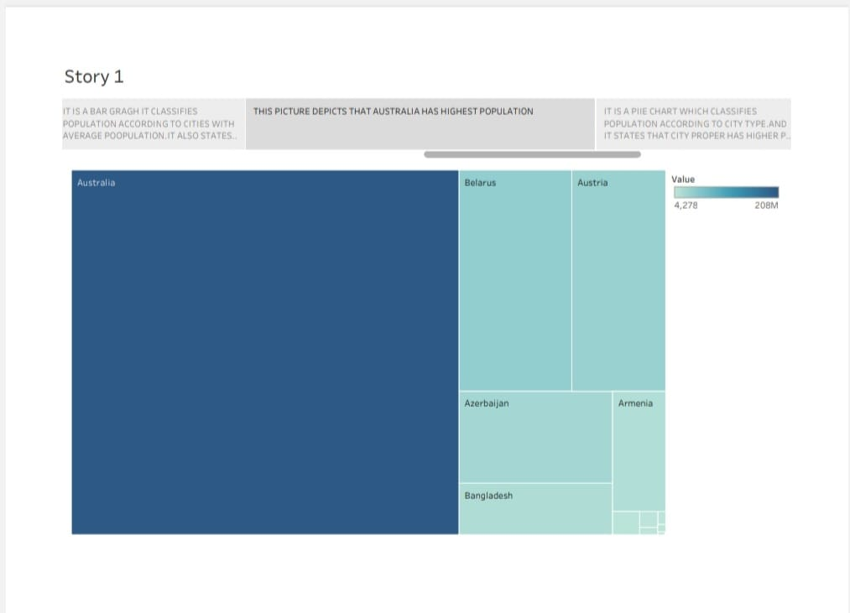

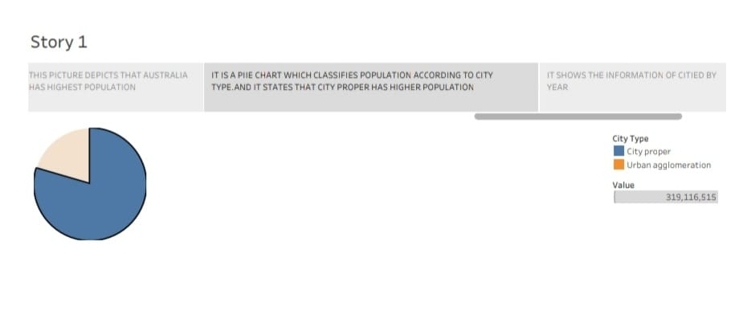

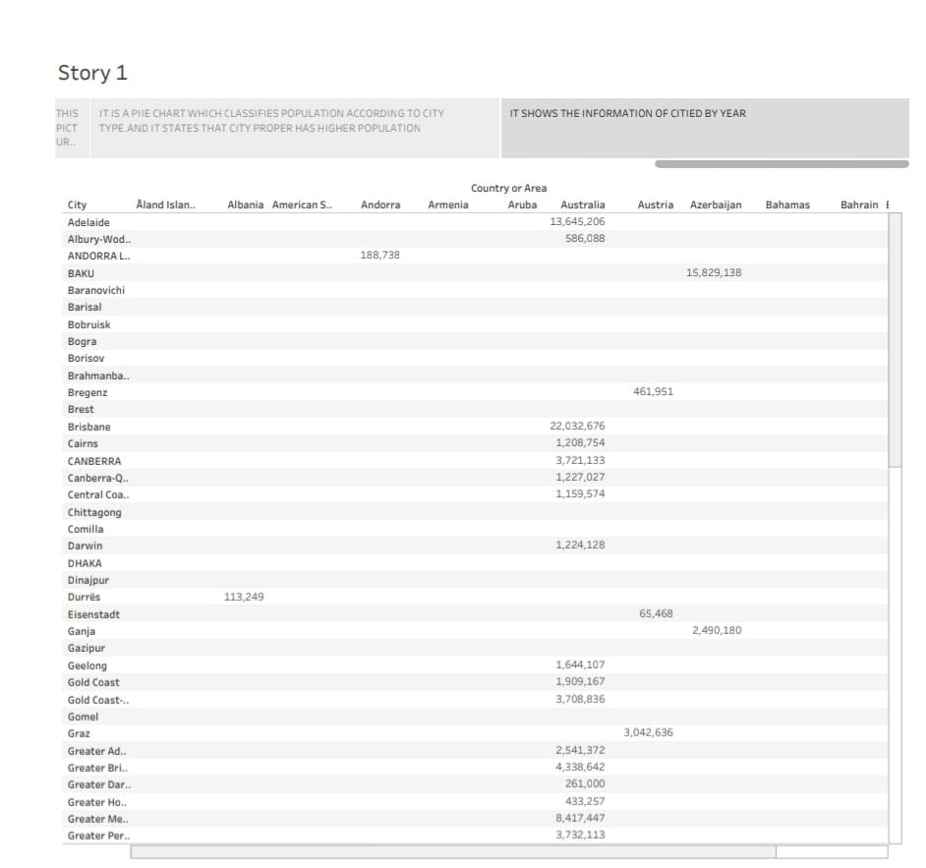

1. **ADVANTAGES AND DISADVANTAGES**

|  |  |
| --- | --- |
| **ADVANTAGES** | **DISADVANTAGES** |
| * Increased human capital. | * Increased pressures on natural environment. |
| * More scope for innovation, invention and creative genius. | * Water shortages and increased population. |
| * Economies of scale from higher   population. | * Exacerbates global warming. |
| * Enables specialisation. | * More waste creation and Congestion. |
| * Higher population densities more efficient. | * Over-use of non-renewable resources. |

1. **APPLICATIONS**

Population projections can be used as a tool to provide information on possible scenarios of future population and, namely, to support decision-making processes in diverse socio-economic areas, such as, higher education institutional network planning, both in public and private sectors.

1. **CONCLUSION**

The projection also shows that we will likely not see a rapid increase in the number of children in the world – we are likely not quite there yet, but the world is close to ‘peak child’.

The projection also shows that we will likely not see a rapid increase in the number of children in the world – we are likely not quite there yet, but the world is close to ‘peak child’.

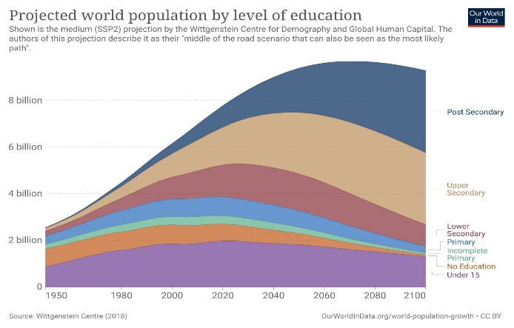

1. **FUTURE SCOPE**

The population of a country or area grows or declines through the interaction of three demographic factors: fertility, mortality, and migration. To project future population, demographers make assumptions about how the current rates of births, deaths, and immigration and emigration will change in the future.

1. **APPENDIX**

Sources:

[**https://www.google.com/search?q=what+is+the+use+of+populationforecasting&oq=what+is+the+use+of+populationforecasting&aqs=chrome..69i57j33i10i160l2.11846j0j7&client=ms-android-samsung-ga-rev1&sourceid=chrome-mobile&ie=UTF-8**](https://www.google.com/search?q=what+is+the+use+of+populationforecasting&oq=what+is+the+use+of+populationforecasting&aqs=chrome..69i57j33i10i160l2.11846j0j7&client=ms-android-samsung-ga-rev1&sourceid=chrome-mobile&ie=UTF-8)

**https://www.google.com/search?q=future+scope+for++population+forecasting&client=ms-android-samsung-ga-rev1&sxsrf=APwXEded5_wCMwWohxY1kPmmD3dbVk-Wzw%3A1681286171416&ei=G2Q2ZO38GPacseMPhNKSoAw&oq=future+scope+for++population+forecasting&gs_lcp=ChNtb2JpbGUtZ3dzLXdpei1zZXJwEAMyCAghEKABEMMEOgoIABBHENYEELADOgUIABCiBEoECEEYAFDfH1idL2DNN2gBcAF4AIAB-gGIAYQRkgEFMC42LjWYAQCgAQHIAQjAAQE&sclient=mobile-gws-wiz-serp**